

Golden Triangle Activation

V1.0

Golden Triangle activation

Activation 2024
As of the first quarter of January 2024, it is obligated to have an active Golden Triangle in support of your personal development. We strongly believe that this will help you take the necessary steps in your development and in this document we explain how you can activate your own Golden Triangle.

In summary, these steps create a structured approach to personal development, ensuring that your goals are well-defined, your progress is tracked, and that you have the support and resources necessary to achieve your desired outcomes. This systematic approach leads to more effective and efficient development, whether you are learning a new skill, improving a current one, or enhancing your work processes.

Step 1: Defining your development goals
This is the starting point of your development journey. It involves identifying specific areas you want to improve or learn more about, whether they relate to skills, tools, or methods. Your goals should be clear, measurable, and aligned with your personal or professional aspirations. You can brainstorm and prioritize your goals to determine what matters most to you.
Talk to your peers if you have a tough time identifying your specific goals. You can also make use of the Competence assessment in Teams. These can help you assess your biggest development points. Also, you can ask Rogier Kamer to help you identifying your goals.

Step 2: Choosing your facilitators
Facilitators are individuals or resources that can help you achieve your development goals. We have a specific training for our employees to become your facilitator. You can find those eligible here. It is important to carefully select facilitators who can provide you with the guidance and knowledge necessary to progress. If you have a tough time identifying the right facilitator, please talk to your peers, or ask Rogier Kamer to help. Once you have selected 2 facilitators, make sure you communicate this with the Development Manager. If, during or after your development period, you want to change your facilitators that is of course possible. It is even smart to do so, a unique perspective can give new impulse on your activities and development.

Step 3: Defining your activities
After choosing your facilitators, you need to outline the specific activities or tasks that will help you reach your goals. These activities can be learning exercises, practical assignments, or any action steps necessary for skill acquisition or development. The activities should be aligned with your goals and facilitators' guidance.
These activities are then collected in TruQu. More information on TruQu below.

Step 4: Planning the sessions
This step involves creating a structured plan for your development sessions. It includes scheduling when and how often you will engage in your development activities, as well as setting deadlines in TruQu for achieving specific milestones. Planning ensures that you allocate time and resources effectively to make progress. We advise you to plan regular sessions, at least once every 3 weeks.

Step 5: Discussing your progress
This step involves creating a structured plan for your development sessions. It includes scheduling when and how often you will engage in your development activities, as well as setting deadlines for achieving specific milestones. Planning ensures that you allocate time and resources effectively to make progress. Reflection should be your most important tool during these discussions. Even reflecting on something that went really well can assist you in your development.

Step 6: Signing off on your goals
Once you have successfully achieved your development goals, it is time to sign off on them. This step signifies that you have met the objectives you set in the first step. Signing off on your goals is a form of acknowledgment and celebration of your achievements. It is also an opportunity to evaluate the impact of your development journey and consider next steps for further growth.
In order to sign off on your goal, we advise you to ask for feedback. This helps you to understand if others are aware of your development and if there are blind spots that might need to be addressed.
Once you complete this step you can move to step 1 and move forward in your development.

TruQu
TruQu is a tool designed for performance and feedback management in a professional or workplace context. TruQu helps you set, track, and achieve your performance goals by collecting and reviewing feedback from your colleagues and using that feedback to make improvements in your professional life. The setting and tracking of your goals is something we discussed in the steps 1 and 5. The feedback is mentioned in Step 6, but here we emphasize the importance of it.
Most of our learning is done by doing. We do, we make mistakes, we fall, we try again, we succeed, and we learn. An outside look on our performance is valuable in that process. Even more so if it is provided by those we work with closest.
TruQu helps us to gather this feedback and combine it with our activities and development goals.

TruQu: Set goals
TruQu allows you to set and track your performance goals. These goals could be related to your job or specific skills you want to improve. In the picture below you can see how to set your goals.

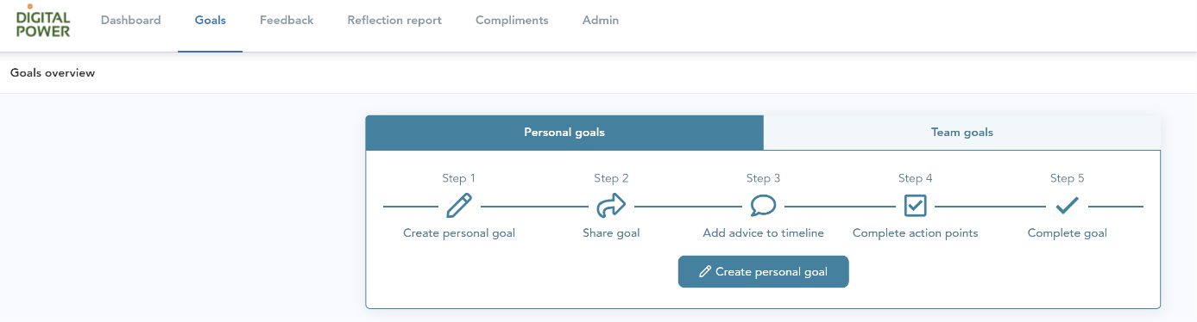
TruQu: Request feedback
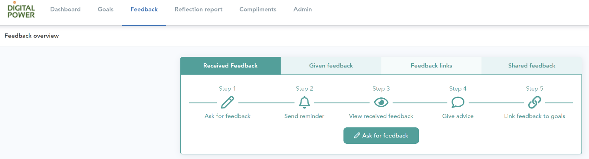
You can ask your colleagues, supervisors, or peers for feedback on your performance. TruQu makes it easy to send feedback requests. Even to people outside of our organisation. Here you can see where you can ask feedback. Once you start that process TruQu helps you define the questions, and you can choose to attach this your development goals. This last step can help those you ask for feedback to understand the context.

TruQu: Reflection
Last big option that can be used in TruQu is the reflection report. Reflection is a cornerstone of personal development because it enables individuals to learn from their experiences, make informed decisions, set meaningful goals, and continuously grow and adapt. It is a process that empowers you to take control of your own development.
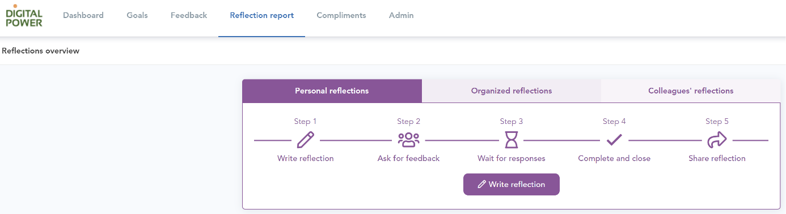
We have multiple templates you can use, but you can also write one by yourself.

